ASSIGNMENT 01
Data Mining
Data Visualization in Data Mining: Techniques, Chart Types and Tools
Student Name: Mussawir Abbas
Roll: 040
Section: BSAI (fall-2024)
Course Instructor: Ms. Hassal

Table of Contents
1. Role of Data Visualization in Data Mining 3
2. Data Visualization Techniques 4
2.1 Pixel-oriented techniques 4
2.2 Geometric projection techniques 4
2.3 Icon-based techniques 5
2.4 Hierarchical techniques 6
2.5 Graph-based techniques 6
2.6 Visualization of complex data 7
3. Common Chart Types 9
3.1 Bar chart 9
3.2 Pie chart 9
3.3 Line graph 10
3.4 Histogram 11
3.5 Scatter plot 11
3.6 Boxplot 12
3.7 Heatmap 13
3.8 Treemap 13
4. Data Visualization Tools and Libraries 15
4.1 Matplotlib 15
4.2 Seaborn 15
4.3 Plotly 15
4.4 Tableau 16
4.5 Microsoft Power BI 16
4.6 Comparison of the tools 16
5. Conclusion 18
References 18
Appendix: Viva Preparation 19

1. Role of Data Visualization in Data Mining
Data visualization is the graphical representation of data using shapes, colours, positions and sizes so that people can see structure that is hard to notice in raw tables of numbers. Data mining is the process of discovering useful patterns, relationships and anomalies in large datasets. Visualization and mining are closely linked: mining algorithms find patterns, and visualization helps humans understand, validate and act on them. The combination of the two is often called visual data mining (Keim, 2002).

1.1 Where visualization fits in the data mining process
Stage | How visualization helps
Data understanding / exploration | Histograms, boxplots and scatter plots reveal distributions, ranges, skewness and relationships before any algorithm is run.
Data preprocessing | Missing-value maps, boxplots and scatter plots expose outliers, noise, duplicates and inconsistent values that need cleaning.
Feature selection | Correlation heatmaps and scatter-plot matrices show which attributes are redundant or informative.
Modelling | Dendrograms, cluster scatter plots, decision-tree diagrams and association-rule graphs show what a model has found.
Evaluation | Confusion-matrix heatmaps, ROC curves and residual plots show how well a model performs and where it fails.
Presentation / deployment | Dashboards and reports communicate results to decision makers who are not data scientists.

1.2 Key roles and benefits
- Exploration: quickly gives an overview of large data and suggests hypotheses (exploratory data analysis, Tukey, 1977).
- Pattern and trend discovery: humans detect clusters, trends, gaps and outliers visually in seconds.
- Outlier and error detection: unusual points stand out in plots even when summary statistics look normal (for example, Anscombe's quartet has identical statistics but very different plots).
- Interpretation of results: makes complex model output (clusters, rules, trees) understandable.
- Communication: charts and dashboards convey findings to non-technical stakeholders.
- Interactivity: zooming, filtering and drill-down let users guide the analysis (Shneiderman's mantra: overview first, zoom and filter, then details on demand).

1.3 Challenges
- Scalability: millions of records exceed the number of available screen pixels, so overplotting occurs.
- High dimensionality: screens are 2-D, but data often has tens or hundreds of attributes.
- Perception bias: poor colour, scale or chart choices can mislead the viewer.

2. Data Visualization Techniques
Han, Kamber and Pei (2012) group visualization methods into five families: pixel-oriented, geometric projection, icon-based, hierarchical and graph-based, plus methods for complex data. Each family solves the problem of showing many records or many dimensions on a limited screen in a different way.

2.1 Pixel-oriented techniques
Purpose. To visualize very large datasets by using the screen space as efficiently as possible, mapping each data value to one coloured pixel.
Working. For an m-dimensional dataset, the window is divided into m sub-windows, one per attribute. Each record is shown as a single pixel in every sub-window, and the pixel colour encodes the attribute value (for example, light = low, dark = high). Records are placed by a fixed order, such as sorted by one attribute, in a left-to-right or a space-filling arrangement (recursive pattern or Hilbert/Peano curves) so that nearby records stay near each other. Corresponding pixels in different windows belong to the same record, so correlations show up as similar colour patterns.
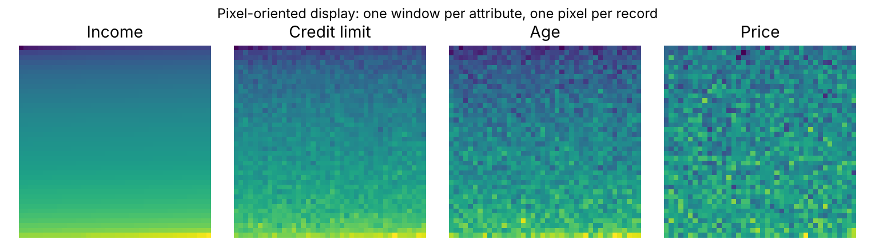
Figure 1: Pixel-oriented display of four attributes sorted by the first attribute (illustrative data).
- Advantages: can display up to roughly as many records as there are pixels (about a million on a typical screen); no overlap; shows all attributes at once; good for spotting correlations and gaps.
- Limitations: exact values cannot be read; colour is hard to compare precisely; the pixel layout and ordering strongly influence what patterns appear; interpretation needs training.
Use cases. Large transaction databases, stock-market data, customer attributes (income, credit limit, age) in banking and retail, and network-log analysis.

2.2 Geometric projection techniques
Purpose. To find interesting projections of multidimensional data onto a 2-D display so that relationships between attributes become visible.
Working. Records are drawn as geometric objects in a coordinate system. Main methods are: scatter plots and scatter-plot matrices (every pair of attributes plotted against each other), parallel coordinates (each attribute is a vertical axis and each record is a polyline crossing the axes, Inselberg, 1985), landscapes/prosection views, and projection pursuit or dimension-reduction methods such as PCA, t-SNE and UMAP that compute 2-D coordinates.
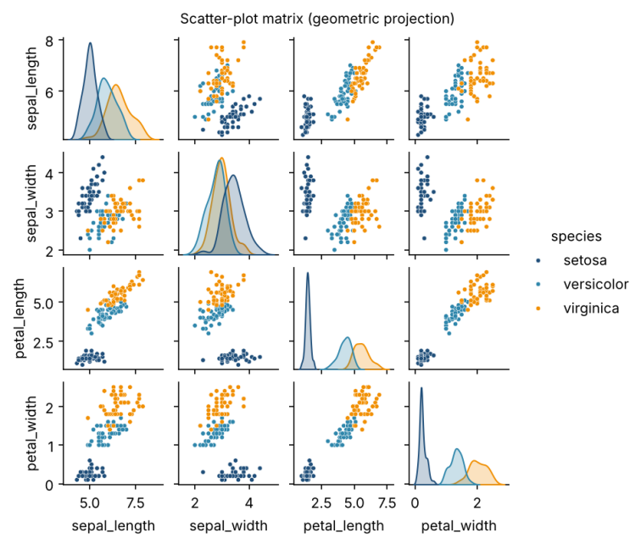
Figure 2: Scatter-plot matrix of the Iris dataset.
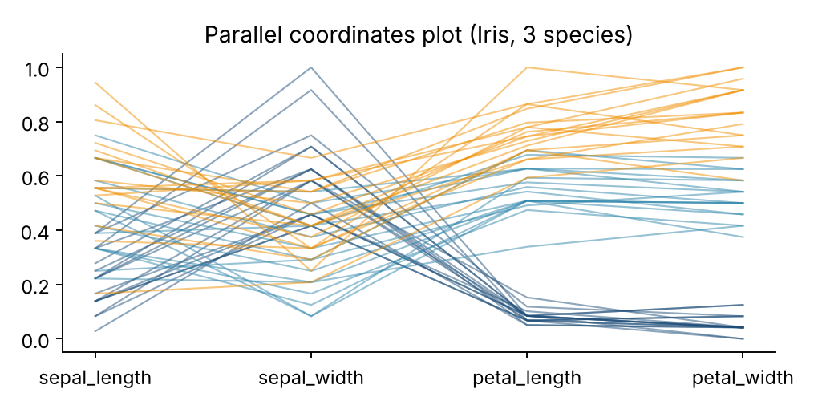
Figure 3: Parallel coordinates plot of the Iris dataset (attributes scaled to 0-1).
- Advantages: familiar, intuitive, shows correlations, clusters and outliers; parallel coordinates can show many dimensions; supports interaction (brushing, linking).
- Limitations: clutter and overplotting with many records; a scatter matrix grows quadratically with dimensions; parallel coordinates depend on axis order; projections lose information.
Use cases. Exploring clusters and class separation before classification, checking correlations among features, and visual comparison of multivariate records.

2.3 Icon-based techniques
Purpose. To show multidimensional records using small graphical icons (glyphs) whose features represent attribute values, so the viewer can compare many records at a glance.
Working. Each attribute is mapped to a feature of an icon. Common icons are Chernoff faces (eye size, mouth curve, nose length and so on; Chernoff, 1973), stick figures (limb angles and lengths; texture patterns emerge across many figures) and star glyphs (one spoke per attribute, spoke length = value). Icons are placed on a grid or at positions given by two chosen attributes.
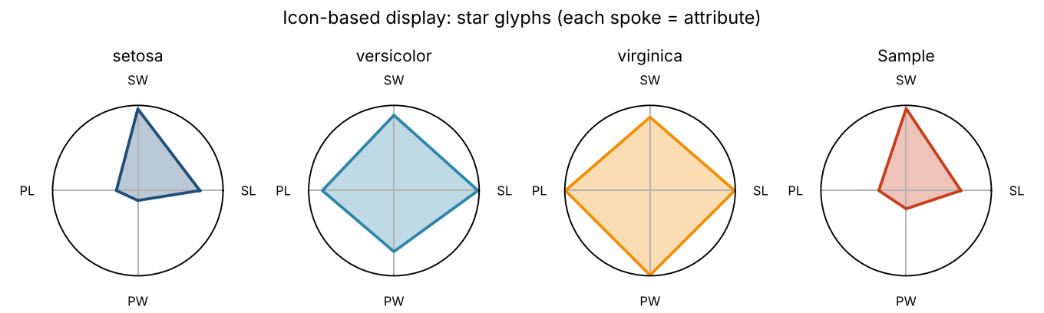
Figure 4: Star glyphs showing mean attribute profiles of the three Iris species and a sample record.
- Advantages: compact way of showing several attributes per record; humans quickly compare shapes; faces exploit our skill at recognising facial differences.
- Limitations: only suits a limited number of records and attributes (usually below about 20 to 30 attributes); the mapping of attributes to features affects what is noticed; precise values cannot be read; faces can be subjective and culturally biased.
Use cases. Comparing a small set of entities such as countries, products, patients or sports players on several indicators.

2.4 Hierarchical techniques
Purpose. To visualize data that is naturally nested or that has been partitioned into a hierarchy, and to handle high-dimensional data by subdividing the screen.
Working. The display space is recursively partitioned according to the hierarchy. Well-known methods are: dendrograms (tree diagrams for hierarchical clustering), treemaps (nested rectangles whose area is proportional to a value, Shneiderman, 1992), sunburst charts (radial treemaps), worlds-within-worlds / n-vision (nesting one coordinate system inside another to reach more dimensions), and cone trees for 3-D hierarchies.
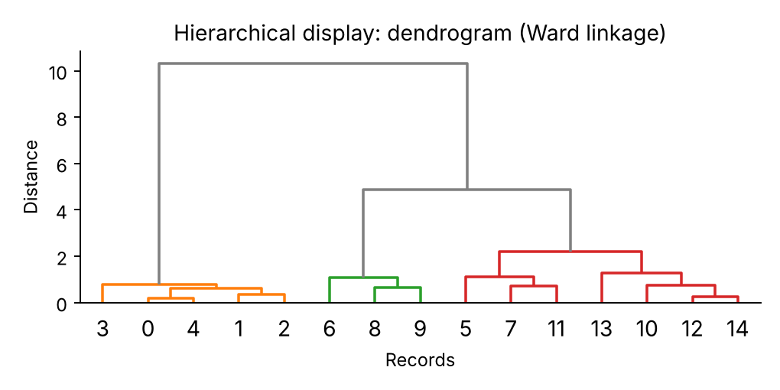
Figure 5: Dendrogram from hierarchical (Ward) clustering.
- Advantages: shows structure and levels of detail; treemaps use all available space; dendrograms show how clusters merge and help choose the number of clusters.
- Limitations: needs a meaningful hierarchy; deep levels become small and unreadable; comparing sizes of areas is less accurate than comparing lengths; dendrograms get unreadable for thousands of leaves.
Use cases. File-system usage, organisation charts, product categories and sales, taxonomy and ontology browsing, hierarchical clustering results, and market segmentation.

2.5 Graph-based techniques
Purpose. To visualize relationships and connectivity between entities, where the main information is who is connected to whom.
Working. Data is modelled as a graph of nodes (entities) and edges (relationships). A layout algorithm (force-directed such as Fruchterman-Reingold, circular, hierarchical or arc diagrams) places nodes so that connected nodes are close and edges cross as little as possible. Visual attributes encode information: node size = degree or importance, colour = community or class, edge thickness = strength. Alternatives for dense graphs include adjacency matrices and edge bundling.
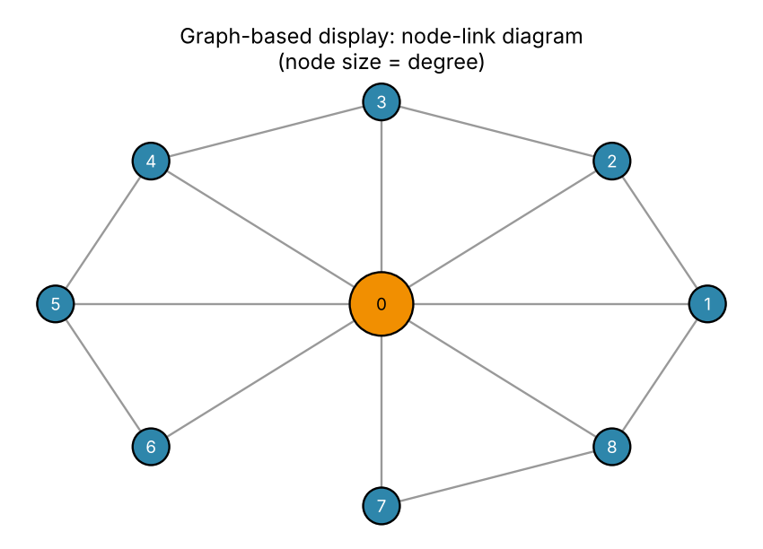
Figure 6: Node-link diagram. Node 0 is a hub; larger size means higher degree.
- Advantages: natural display for networks; reveals hubs, communities, bridges and isolated nodes; supports exploration by zooming and filtering.
- Limitations: the 'hairball' problem for large or dense graphs; layouts are not unique and may not scale; edge crossings reduce readability; high computational cost for layout.
Use cases. Social-network analysis, fraud-ring detection, web-link structure, telecom networks, biological pathways, and association-rule or itemset networks.

2.6 Visualization of complex data and relations
Purpose. To display data that is not a simple table of numbers: text, documents, streams, images, spatial data, multimedia and complex relations.
Working. Special encodings are used for each data type. Tag clouds show word frequency by font size (text). Time-series and stream views use line plots, horizon graphs and calendar views. Maps and choropleths show spatial data. Image montages and thumbnails show image collections. Word trees, topic maps and Sankey diagrams show relations in text and flows. Dimension-reduction (t-SNE, UMAP) turns high-dimensional embeddings into 2-D maps. Large unstructured data is often combined with interactive dashboards.
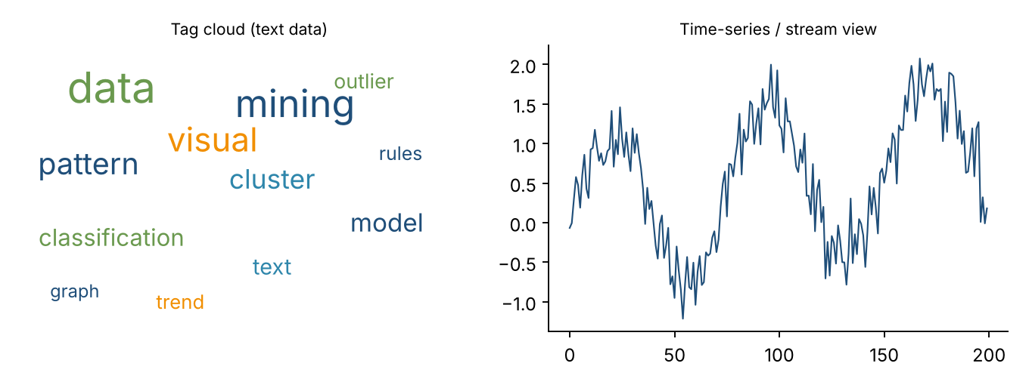
Figure 7: Examples for complex data: tag cloud for text (left) and time-series view (right).
- Advantages: makes unstructured or non-numeric data accessible; supports exploration of text and social media; gives a quick summary of large collections.
- Limitations: often needs preprocessing (tokenisation, embedding, aggregation); the encoding may be misleading (for example, tag clouds ignore context and word length affects perception); each data type needs its own technique.
Use cases. Customer reviews and social-media text mining, sensor and IoT stream monitoring, geographic analysis, medical images, and document collections.

2.7 Summary comparison of the technique families
Technique | Main idea | Best for | Main weakness
Pixel-oriented | One pixel per value, one window per attribute | Very large data | Hard to read exact values
Geometric projection | Records as points/lines in axes | Correlation, clusters | Clutter, many dimensions
Icon-based | Attributes mapped to glyph features | Small sets of records | Limited scalability
Hierarchical | Recursive partitioning of space | Nested / tree-like data | Needs a hierarchy
Graph-based | Nodes and edges | Networks, relations | Hairball effect
Complex data | Type-specific encodings | Text, streams, maps, images | Needs preprocessing

3. Common Chart Types
This section explains eight widely used charts: their purpose, how they work, advantages, limitations and suitable use cases. The figures were produced with Python (Matplotlib and Seaborn) using sample data.

3.1 Bar chart
Purpose. To compare the magnitude of a numeric value across discrete categories.
Working. Each category is a bar on one axis; bar length (or height) is proportional to the value on the other axis. Bars can be vertical or horizontal, grouped (side by side) or stacked to show sub-categories. The baseline should start at zero.
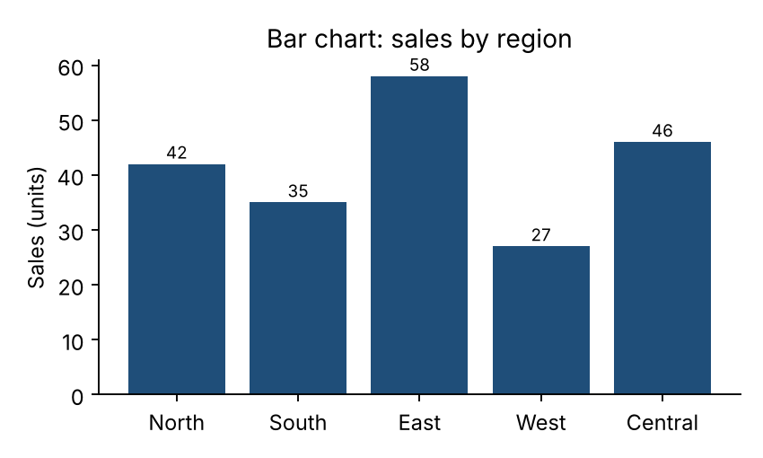
Figure 8: Bar chart of sales by region.
Advantages
- Very easy to read and compare; accurate because length is judged on a common baseline.
- Works for many categories (horizontal bars handle long labels).
- Supports grouped and stacked variants.
Limitations
- Not suitable for continuous data (use a histogram) or for many time points.
- Truncated axes exaggerate differences.
- Stacked bars make comparison of inner segments difficult.
Suitable use cases. Sales by region, counts per class label in a dataset, survey responses, comparison of model accuracy.

3.2 Pie chart
Purpose. To show how a whole is divided into parts (part-to-whole composition).
Working. A circle is split into slices; the angle (and area) of each slice is proportional to the category's share of the total, so slices add up to 100%. Labels or percentages are usually written on or beside slices. A donut chart is a variant with a hole in the centre.
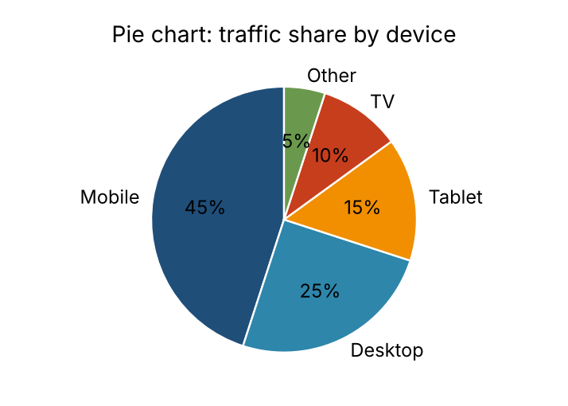
Figure 9: Pie chart showing share of traffic by device.
Advantages
- Instantly communicates that parts form a whole.
- Simple and familiar to non-technical audiences.
- Works well when there are two to five categories and one dominant slice.
Limitations
- Humans compare angles and areas poorly, so similar slices are hard to rank.
- Becomes unreadable with many slices.
- Cannot show change over time or negative values.
Suitable use cases. Market share, budget split, proportion of classes in a dataset (with few classes), percentage of missing versus complete data.

3.3 Line graph
Purpose. To show trends, changes and patterns in a continuous measure, normally over time.
Working. Data points are plotted against an ordered (usually time) x-axis and joined by line segments. Multiple lines compare series. The slope shows the rate of change, and peaks, dips and seasonality are visible.
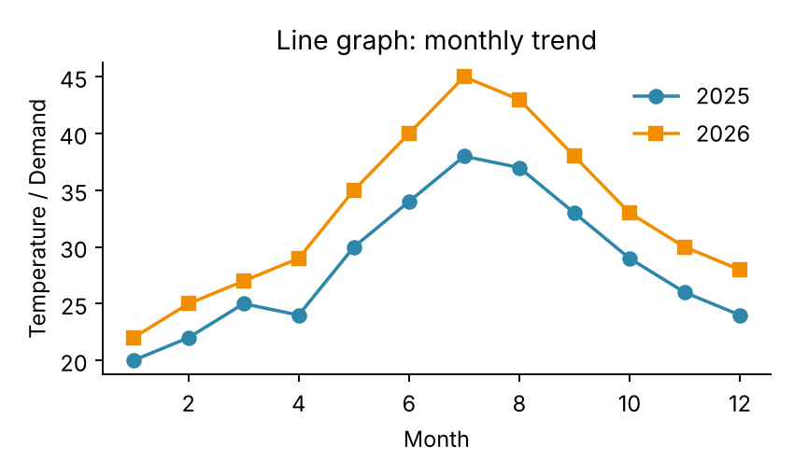
Figure 10: Line graph comparing monthly values for two years.
Advantages
- Best choice for time-series and trend analysis.
- Can compare several series on one chart.
- Shows rate of change, seasonality and turning points.
Limitations
- Too many lines create clutter.
- Misleading if the x-axis is not evenly spaced or the y-axis is truncated.
- Connecting points implies continuity that may not exist.
Suitable use cases. Stock prices, sales over months, sensor readings, model training and validation loss per epoch, website traffic.

3.4 Histogram
Purpose. To show the frequency distribution of a single continuous numeric variable.
Working. The value range is divided into equal-width intervals called bins. A bar is drawn for each bin with height equal to the number (or density) of observations in it. Adjacent bars touch, because the data are continuous.
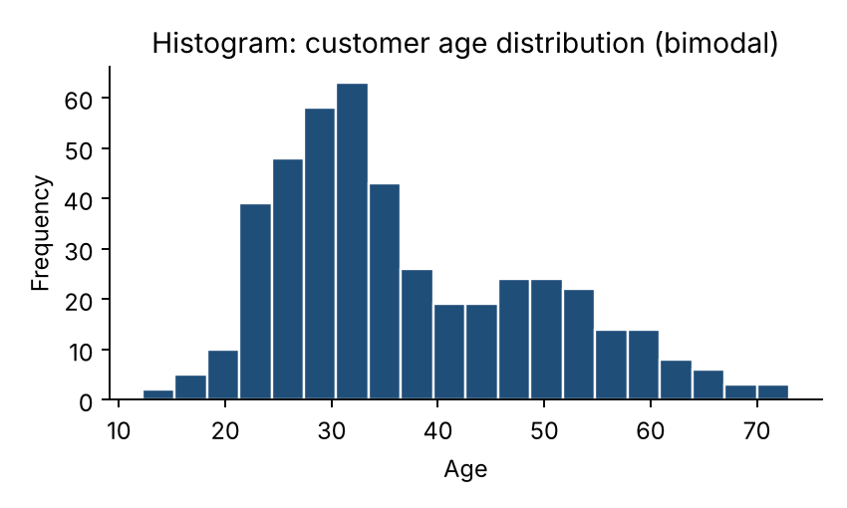
Figure 11: Histogram of customer age showing two peaks (bimodal distribution).
Advantages
- Shows shape of distribution: skewness, spread, modality and gaps.
- Helps detect outliers and choose preprocessing steps such as transformation or normalisation.
- Works for large datasets.
Limitations
- Appearance depends heavily on the bin width and starting point.
- Shows only one variable at a time.
- Individual values and exact statistics are lost.
Suitable use cases. Distribution of age, income or exam scores; checking normality before applying a statistical model; detecting skewed attributes.

3.5 Scatter plot
Purpose. To show the relationship between two numeric variables and reveal correlation, clusters and outliers.
Working. Each record is a point positioned by its x and y values. A third variable can be added with colour or size (bubble chart). A regression line may be added. Pattern direction shows correlation: upward = positive, downward = negative, shapeless = none.
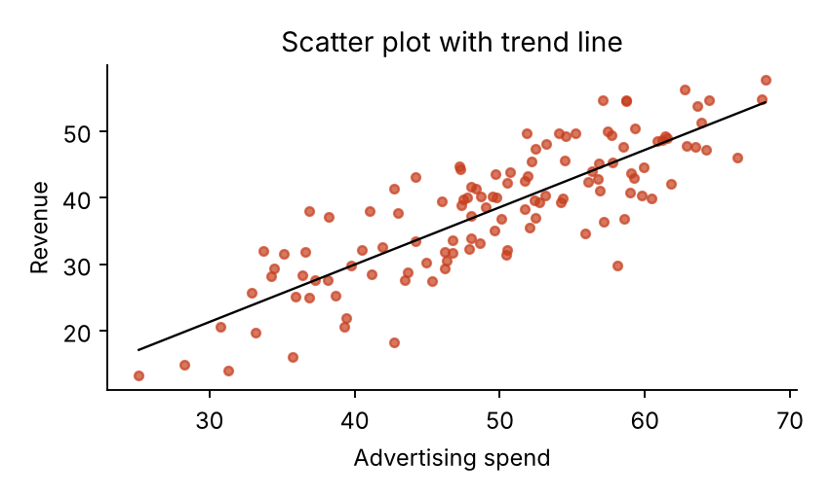
Figure 12: Scatter plot with a fitted trend line showing positive correlation.
Advantages
- Reveals correlation, non-linear patterns, clusters and outliers.
- Shows every data point.
- Basis of scatter-plot matrices and many clustering displays.
Limitations
- Overplotting with very large datasets (use transparency, sampling or hexbin).
- Only two (or at most four with colour and size) variables.
- Correlation does not prove causation.
Suitable use cases. Advertising spend versus revenue, height versus weight, visualising clusters from k-means, feature relationships and outlier detection.

3.6 Boxplot
Purpose. To summarise the distribution of a numeric variable using five key statistics and to compare distributions between groups.
Working. The box spans the first to the third quartile (Q1 to Q3, the interquartile range, IQR), with a line at the median. Whiskers extend to the most extreme values within 1.5 x IQR from the box; points beyond are plotted individually as outliers (Tukey, 1977).
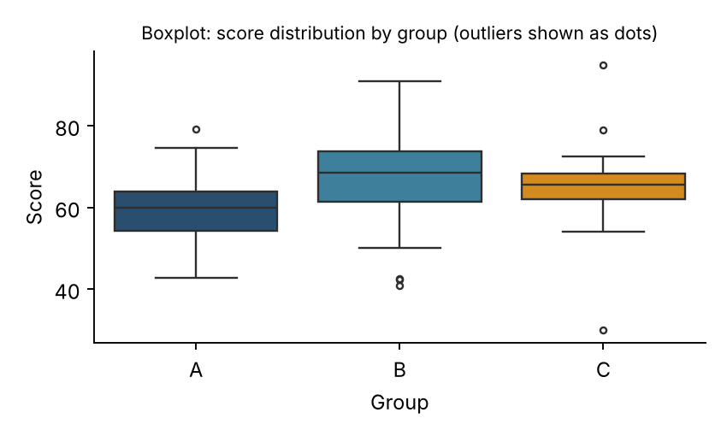
Figure 13: Boxplots comparing score distribution of three groups.
Advantages
- Compact; many groups can be compared side by side.
- Shows median, spread, skewness and outliers clearly.
- Robust to extreme values.
Limitations
- Hides the shape of the distribution (for example, bimodality); violin plots can fix this.
- Less intuitive for non-technical audiences.
- Does not display sample size unless annotated.
Suitable use cases. Comparing salaries across departments, detecting outliers during preprocessing, comparing model performance across cross-validation folds.

3.7 Heatmap
Purpose. To display values in a matrix using colour intensity so that patterns and hot spots are easy to see.
Working. Rows and columns represent two categorical or ordered dimensions and each cell is coloured according to its value using a colour scale. Rows and columns are often reordered by clustering (clustered heatmap). Values may be written in the cells.
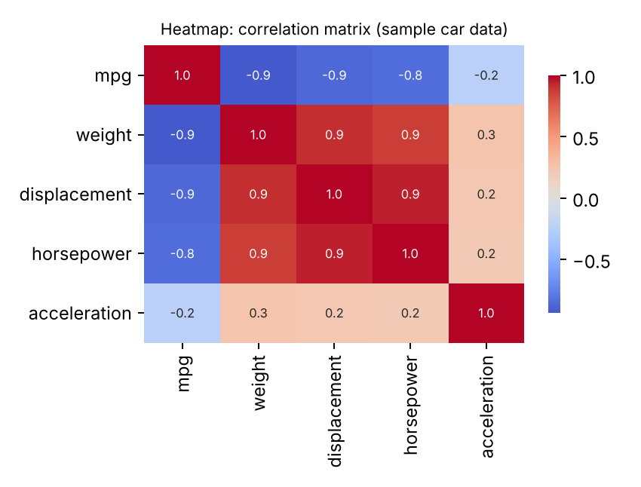
Figure 14: Heatmap of a correlation matrix (sample car data).
Advantages
- Shows patterns in large tables at a glance.
- Ideal for correlation matrices, confusion matrices and gene-expression data.
- Compact: hundreds of rows and columns fit on one screen.
Limitations
- Colour is less precise than position or length for reading exact values.
- Colour-scale choice affects interpretation and accessibility (avoid red-green).
- Order of rows and columns changes the visible pattern.
Suitable use cases. Feature correlation analysis, confusion matrix of a classifier, website click density, missing-data patterns, gene expression.

3.8 Treemap
Purpose. To show hierarchical, part-to-whole data in a compact space using nested rectangles.
Working. The display area is split into rectangles, one per category, with area proportional to a quantitative value such as sales. Each rectangle can be subdivided to show child categories, and colour often encodes a second variable (for example, growth). Layouts such as slice-and-dice or squarified are used (Shneiderman, 1992).
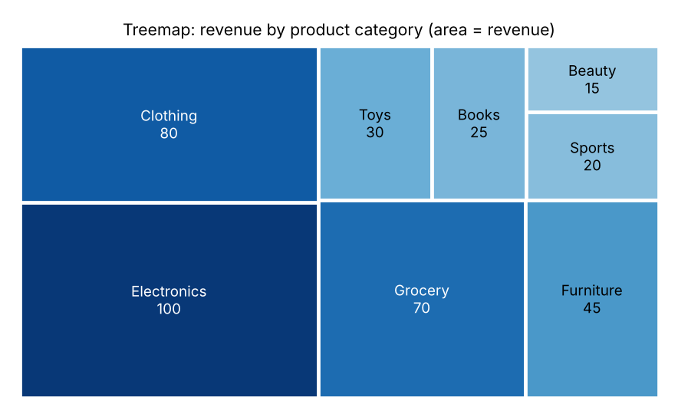
Figure 15: Treemap of revenue by product category.
Advantages
- Uses space very efficiently; handles thousands of items.
- Shows hierarchy and proportion together.
- Colour can add a second measure.
Limitations
- Area is hard to compare accurately.
- Not suitable for negative values or showing change over time.
- Deep hierarchies and very small items become unreadable.
Suitable use cases. Disk-space usage, revenue by category and sub-category, stock-market sectors, budget breakdown, and population by region.

3.9 Quick guide: which chart to use?
Goal | Recommended chart | Avoid
Compare categories | Bar chart | Pie with many slices
Part-to-whole (few parts) | Pie / donut, stacked bar | Pie with more than five slices
Trend over time | Line graph | Bar chart for dense time series
Distribution of one variable | Histogram, boxplot | Bar chart
Relationship between two variables | Scatter plot | Line graph (unless ordered)
Compare distributions across groups | Boxplot (or violin) | Many overlapping histograms
Pattern in a matrix / correlations | Heatmap | Plain table of numbers
Hierarchical proportions | Treemap, sunburst | Pie charts nested several levels

4. Data Visualization Tools and Libraries
Visualization tools can be divided into programming libraries (Matplotlib, Seaborn, Plotly) that give full flexibility inside code, and business-intelligence (BI) tools (Tableau, Microsoft Power BI) that offer drag-and-drop dashboards.

4.1 Matplotlib
Matplotlib is the foundational Python plotting library (Hunter, 2007). It offers fine control over every element of a figure and works with NumPy and pandas. Many other libraries, including Seaborn, are built on top of it.
import matplotlib.pyplot as plt
regions = ['North','South','East','West']
sales = [42, 35, 58, 27]
plt.bar(regions, sales, color='#1F4E79')
plt.title('Sales by region'); plt.ylabel('Units')
plt.savefig('bar.png', dpi=150); plt.show()
- Advantages: extremely flexible; supports almost all 2-D chart types; publication-quality output (PNG, PDF, SVG); free and open source; huge community.
- Limitations: verbose code for complex charts; default look is plain; limited built-in interactivity; steeper learning curve for fine tuning.
Applications. Research papers, custom plots, teaching, and the base for scientific and machine-learning visualizations.

4.2 Seaborn
Seaborn is a high-level statistical visualization library built on Matplotlib and tightly integrated with pandas DataFrames (Waskom, 2021). It provides attractive default styles and one-line statistical plots.
import seaborn as sns
sns.boxplot(data=df, x='group', y='score')
sns.heatmap(df.corr(), annot=True, cmap='coolwarm')
sns.pairplot(df, hue='species')
- Advantages: concise code; good defaults and colour palettes; built-in statistical plots (box, violin, pair, regression, heatmap, KDE); works directly with DataFrames.
- Limitations: less control than Matplotlib (customisation often needs Matplotlib commands); mainly static plots; focused on statistical graphics, so it is not designed for dashboards or maps.
Applications. Exploratory data analysis, correlation and distribution analysis, feature exploration before modelling.

4.3 Plotly
Plotly is an open-source library for interactive charts in Python, R and JavaScript. Charts are rendered in the browser with hover tooltips, zoom, pan and selection. Plotly Express offers a concise high-level API, and the Dash framework turns Plotly charts into web applications.
import plotly.express as px
fig = px.scatter(df, x='spend', y='revenue', color='region',
size='profit', hover_name='city')
fig.show()
- Advantages: interactive by default; many chart types (3-D, maps, treemaps, sunburst, Sankey); easy web and dashboard deployment with Dash; exports to HTML.
- Limitations: large datasets can slow the browser; static image export needs extra packages; some advanced features and hosting belong to commercial offerings; smaller ecosystem for publication-style figures than Matplotlib.
Applications. Interactive exploratory analysis, web dashboards, notebooks, geographical and 3-D visualization.

4.4 Tableau
Tableau is a commercial visual analytics platform that lets users build interactive visualizations and dashboards by dragging and dropping fields, without programming. It connects to spreadsheets, databases, cloud services and big-data sources, and publishes through Tableau Server, Cloud or the free Tableau Public.
- Advantages: very strong and polished visuals; fast drag-and-drop exploration; handles large data with live or extracted connections; powerful interactivity (filters, actions, drill-down); strong community.
- Limitations: paid licences are costly; limited data-preparation and modelling features compared with code; less flexible for fully custom analytics; Tableau Public data is publicly visible.
Applications. Business and sales analytics, executive dashboards, data journalism, and exploration by analysts without coding skills.

4.5 Microsoft Power BI
Power BI is Microsoft's business-intelligence suite, consisting of Power BI Desktop (authoring), the Power BI Service (cloud sharing) and mobile apps. It uses Power Query for data cleaning and the DAX language for calculations, and integrates closely with Excel, Azure and other Microsoft products.
- Advantages: low cost and a free desktop version; excellent integration with Excel and the Microsoft ecosystem; built-in data transformation (Power Query) and modelling (DAX); easy sharing and scheduled refresh; AI-assisted visuals.
- Limitations: Desktop authoring runs on Windows only; DAX has a learning curve; fewer visual customisation options than Tableau; large datasets and sharing require paid capacity or licences.
Applications. Corporate reporting, KPI dashboards, financial and operational monitoring, and organisations already using Microsoft 365.
Screenshot placeholders: add a screenshot of a sample dashboard created in Tableau and in Power BI here (see note below).

4.6 Comparison of the tools
Feature | Matplotlib | Seaborn | Plotly | Tableau | Power BI
Type | Python library | Python library | Python/R/JS library | BI software | BI software
Coding needed | Yes | Yes (less) | Yes (less) | No | No (DAX optional)
Interactivity | Limited | Limited | High | Very high | High
Ease of learning | Moderate to hard | Easy to moderate | Easy to moderate | Easy | Easy
Customisation | Very high | Medium | High | High | Medium
Dashboards | No (manual) | No | Yes (Dash) | Yes | Yes
Statistical plots | Basic | Excellent | Good | Good | Basic
Big-data handling | Limited by memory | Limited by memory | Moderate (browser) | Strong | Strong
Cost | Free | Free | Free core / paid | Paid (Public free) | Free Desktop / paid Service
Best for | Custom/publication plots | Statistical EDA | Interactive web plots | Business analytics | Microsoft-centred reporting

Which to choose? Use Matplotlib or Seaborn for analysis inside a data-mining workflow in Python, Plotly when the audience needs interactive plots or a web app, and Tableau or Power BI when the goal is a shareable business dashboard for non-programmers.

